# Science Fair 2009



# Thursday 23rd April

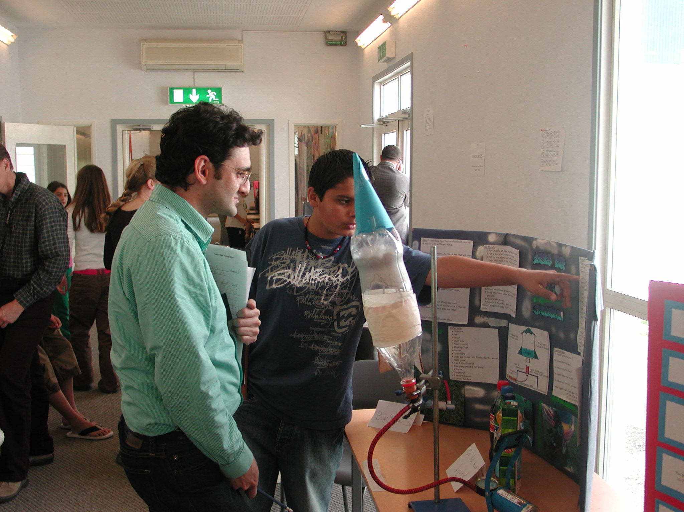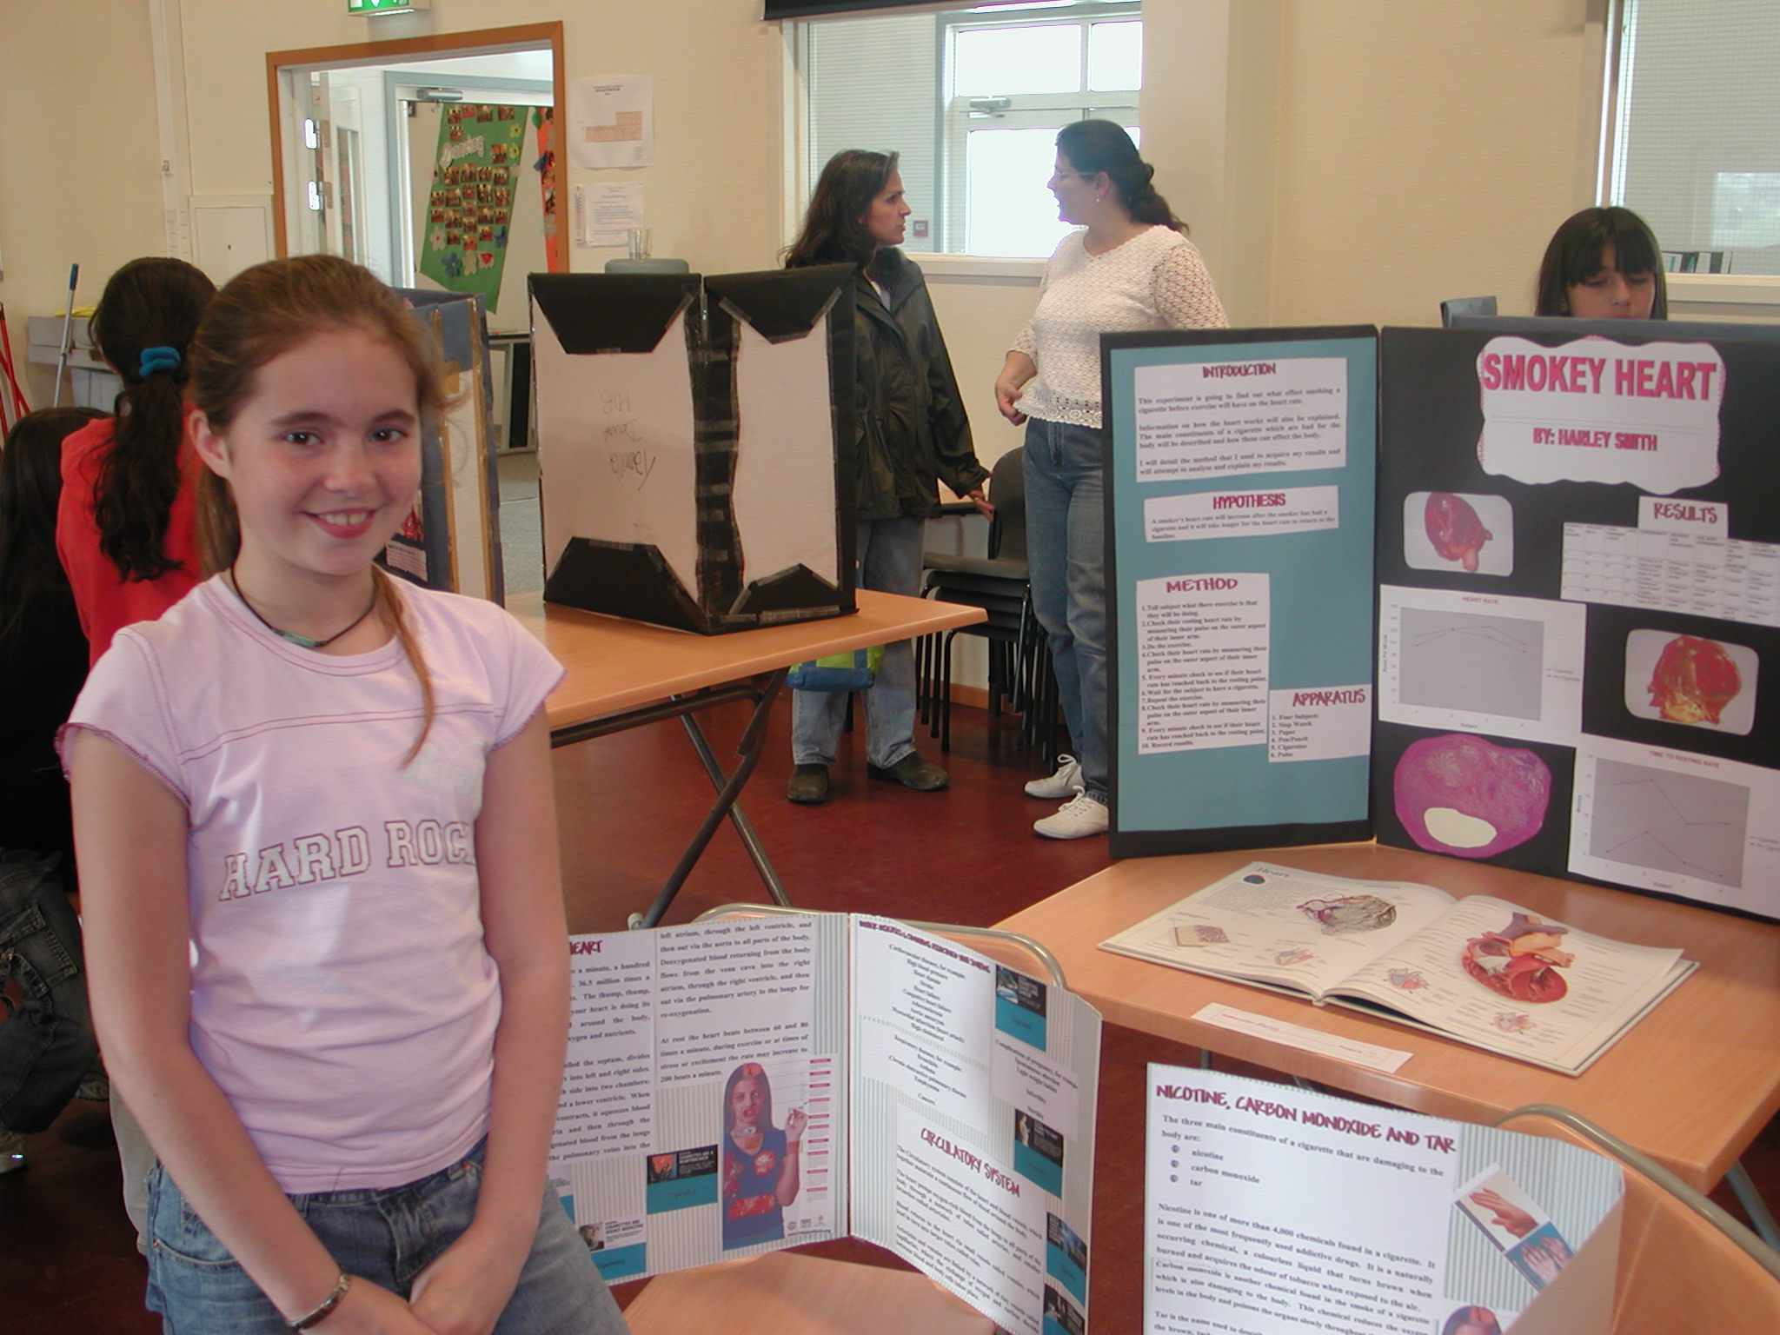

**CONTENTS**

**Rules for the projects**

**How the projects will be judged**

**Judging criteria**

**Rules for the projects**

During April M1-M3 students will plan and then produce a Research Project on a topic of their choice that they will present for judging on the morning of Thursday 23rd April.

The Science Fair project will have two components.

1. The Science Fair Projects are judged on the day by our team of judges.

2. Each student will submit a project report, by Friday 1st May that will count towards their term 3 Science grade.

**Some preliminary Information**

Students must perform an experiment that has a hypothesis, an independent and dependent variable, and gives measurable results that can be analysed, and from which they can formulate a conclusion and evaluation.

Projects that are NOT SUITABLE are such things as: ‘building a model’ of something, or ‘making a poster’ or anything that does not permit the collection and processing of numerical data.

Students are advised to work on their own project, rather than with a partner as their project will contribute to their Term 3 grades. If however, students work with a partner, they can share the same topic but must produce independent investigations under the same topic.

**Display of Project**

Each student will be given a 3 panel display board to present their data as they see fit. A suggested format is given below, but you are in no way constrained to us it. Ms. Reynolds will be coming into Science classes to offer advice on how to get the most out of your display.

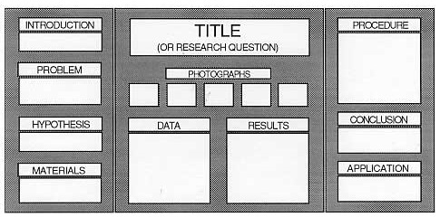

*You do not need to use all above headings, this is just an example of a triptex display.*

Project guidance sheet



**Use this sheet to help focus your project. If you cannot answer ALL of these questions your project may not be suitable. Please ask your teacher for advice.**

**Aim:** This section should **define** the purpose of the investigation.

____________________________________________________________________

**Hypothesis:** **formulate a testable hypothesis** and **explain** the hypothesis using scientific reasoning.

_____________________________________________________________________

______________________________________________________________________

_______________________________________________________________________

_______________________________________________________________________

______________________________________________________________________

_______________________________________________________________________

_______________________________________________________________________

**Apparatus:** Usually a list of apparatus and a schematic showing how the apparatus fits together.

**Method:**

What is your independent variable? _______________________________________

What is your dependent variable? _________________________________________

How will you carry out your investigation? ____________________________________

______________________________________________________________________

_______________________________________________________________________

_______________________________________________________________________

______________________________________________________________________

_______________________________________________________________________

_______________________________________________________________________

***When your project is completed***

**Results:**

How will you present your data? In a table? In a graph?

**Conclusion:**

Put here what it is you have found and relate it to your hypothesis.

**Evaluation:** **evaluate** the method commenting on its **reliability** and/or **validity**, suggesting improvements to the method and making suggestions for further inquiry when relevant.

++++++++++++++++++++++++++++++++++++++++++++++++++++++++++++++++++++++

**Reliability:** Refers to measurement of the data. This depends upon the selection of the measuring instrument, the precision and accuracy of the measurements, errors associated with the measurement, the size of the sample, the sampling techniques used, the number of readings.

**Validity:** Refers to the success of the method at measuring what the investigator wishes to measure. This includes factors such as the choice of the measuring instrument and whether this measures what it is supposed to measure, the conditions of the experiment, and variable manipulation (fair testing).

***Remember that EACH STUDENT must submit an individual project report that will be assessed using the MYP criteria for B, D, E and F. These criteria are attached.***

**MYP Assessment Criteria M1 to M3**

|  |  |  |
| --- | --- | --- |
| **Level of Achievement** | | CRITERION B: COMMUNICATION |
| **Student** | Teacher | Descriptor |
| 0 | 0 | The student has not reached a standard described by any of the descriptors given below. |
| 1 – 2 | 1 – 2 | The student is able to recognize basic scientific vocabulary,  The student shows **some ability** to present information in an appropriate form.  The student communicates **some** of his/her ideas using **some scientific language** effectively. |
| 3 – 4 | 3 – 4 | The student is able to recognize and **use a variety** of scientific vocabulary, to present **most information** in an appropriate form and to   The student communicate the **majority** of his/her ideas using scientific language effectively. |
| 5 – 6 | 5 – 6 | The student is able to use and **interpret a wide variety** of scientific language,  The student is able to present **detailed and complex** information appropriately and **accurately**,  The student is able to communicate **even the more difficult** ideas using scientific language effectively. |

|  |  |  |
| --- | --- | --- |
| **Level of Achievement** | | CRITERION D: SCIENTIFIC ENQUIRY |
| **Student** | Teacher | Descriptor |
| 0 | 0 | The student has not reached a standard described by any of the descriptors given below. |
| 1 – 2 | 1 – 2 | The student is able to identify **some** of the variables involved to plan a fair test.  The student can select suitable procedures and apparatus,  The student can make **some relevant comments** as part of the evaluation of the enquiry. |
| 3 – 4 | 3 – 4 | The student is able to **state a problem** on a particular issue,  The student is able to identify the **main variables** involved,  The student is able to **suggest** a reasonable plan for the procedures and the apparatus required.  The student is able to carry out a **mostly relevant evaluation** of the procedures. |
| 5 – 6 | 5 – 6 | The student is able to formulate a **clear and testable** hypothesis,  The student is able to plan how to control **a number** of variables, suggest the procedures and apparatus required, and **comment on the reliability** of the results.  The student is also able to **identify** anomalous results and **suggest** improvements to the procedures. |

|  |  |  |
| --- | --- | --- |
| **Level of Achievement** | | CRITERION E: PROCESSING DATA |
| **Student** | Teacher | Descriptor |
| 0 | 0 | The student has not reached a standard described by any of the descriptors given below. |
| 1 – 2 | 1 – 2 | The student is able to present data in **simple tables**,  The student can transform data using **simple numerical and/or diagrammatic methods**.  The student draws an **obvious** conclusion. |
| 3 – 4 | 3 – 4 | The student is able to construct and use **appropriate** tables and **detect trends and patterns** in the data.  The student is able to draw conclusions **consistent** with evidence, and make **some attempt to explain** conclusions using his/her scientific knowledge and understanding. |
| 5 – 6 | 5 – 6 | The student is able to present his/her results **logically and clearly**,  The student can carry out **relevant** calculations and draw appropriate graphs.  The student can **interpret** trends in data that he/she has obtained.  The student can **draw conclusions consistent** with evidence, and  The student can **clearly explain** the conclusion using relevant scientific knowledge and understanding. |

|  |  |  |
| --- | --- | --- |
| **Level of Achievement** | | CRITERION F: PERFORMANCE IN EXPERIMENTS |
| **Student** | Teacher | Descriptor |
| 0 | 0 | The student has not reached a standard described by any of the descriptors given below. |
| 1 – 2 | 1 – 2 | The student is able to use **simple equipment** following **detailed** instructions,  The student can carry out **simple** procedures, and make **straightforward** observations and measurements.  The student **can work safely and cooperate** with other students, but may need **reminders**. |
| 3 – 4 | 3 – 4 | The student is able use **most equipment** competently following instructions,  The student can carry out procedures involving **several steps**, and make **reasonably systematic and accurate** observations and measurements.  The student **generally** cooperates well with other students and follows safety rules. |
| 5 – 6 | 5 – 6 | The student is able to use equipment with **precision and skill**, following outlined instructions,  The student can obtain **reliable evidence** by making accurate measurements, and repeat observations and measurements as necessary.  The student maintains a **high level** of cooperation with other students and pays attention to safety. |

**How the projects will be judged**



On the morning of the Science Fair you will have time to set up your project in readiness for judging. Each project will be judged twice to ensure fairness.

The judges will use a judging rubric as shown below to judge your project. The judges will also talk to you about your project, so be prepared to answer questions.

At the end of the fair, the total marks for each project will be added up and the results announced as soon as possible. The Science Fair Prizes will be awarded in a school assembly.

**Judges Rubric used to assess your project:**

|  |  |  |  |  |  |  |  |
| --- | --- | --- | --- | --- | --- | --- | --- |
| **Part I Scientific Procedure:** | IMPRESSIVE | | ADEQUATE | | | MINIMAL | |
| Clear & specific Question | 4 | 3 | | 2 | 1 | | 0 |
| Clear & specific Hypothesis | 4 | 3 | | 2 | 1 | | 0 |
| Complete & thorough Method (Step by step) | 4 | 3 | | 2 | 1 | | 0 |
| Complete & thorough Data (graphs, tables, photos...) | 4 | 3 | | 2 | 1 | | 0 |
| Conclusion supported by Data | 4 | 3 | | 2 | 1 | | 0 |
| Conclusion relevant to Hypothesis | 4 | 3 | | 2 | 1 | | 0 |
| **Part II Originality:** |  |  | |  |  | |  |
| Original topic or approach | 4 | 3 | | 2 | 1 | | 0 |
| **Part III Simplicity:** |  |  | |  |  | |  |
| Appropriate apparatus | 4 | 3 | | 2 | 1 | | 0 |
| Clarity of overall project | 4 | 3 | | 2 | 1 | | 0 |
| **TOTAL MARKS** |  |  | |  |  | |  |

TOTAL MARK AWARDED FOR THE PROJECT: .... /36

